3-way handshake (TCP)

Kiran S Raj

(CB.EN.U4CSE17430)

Server :

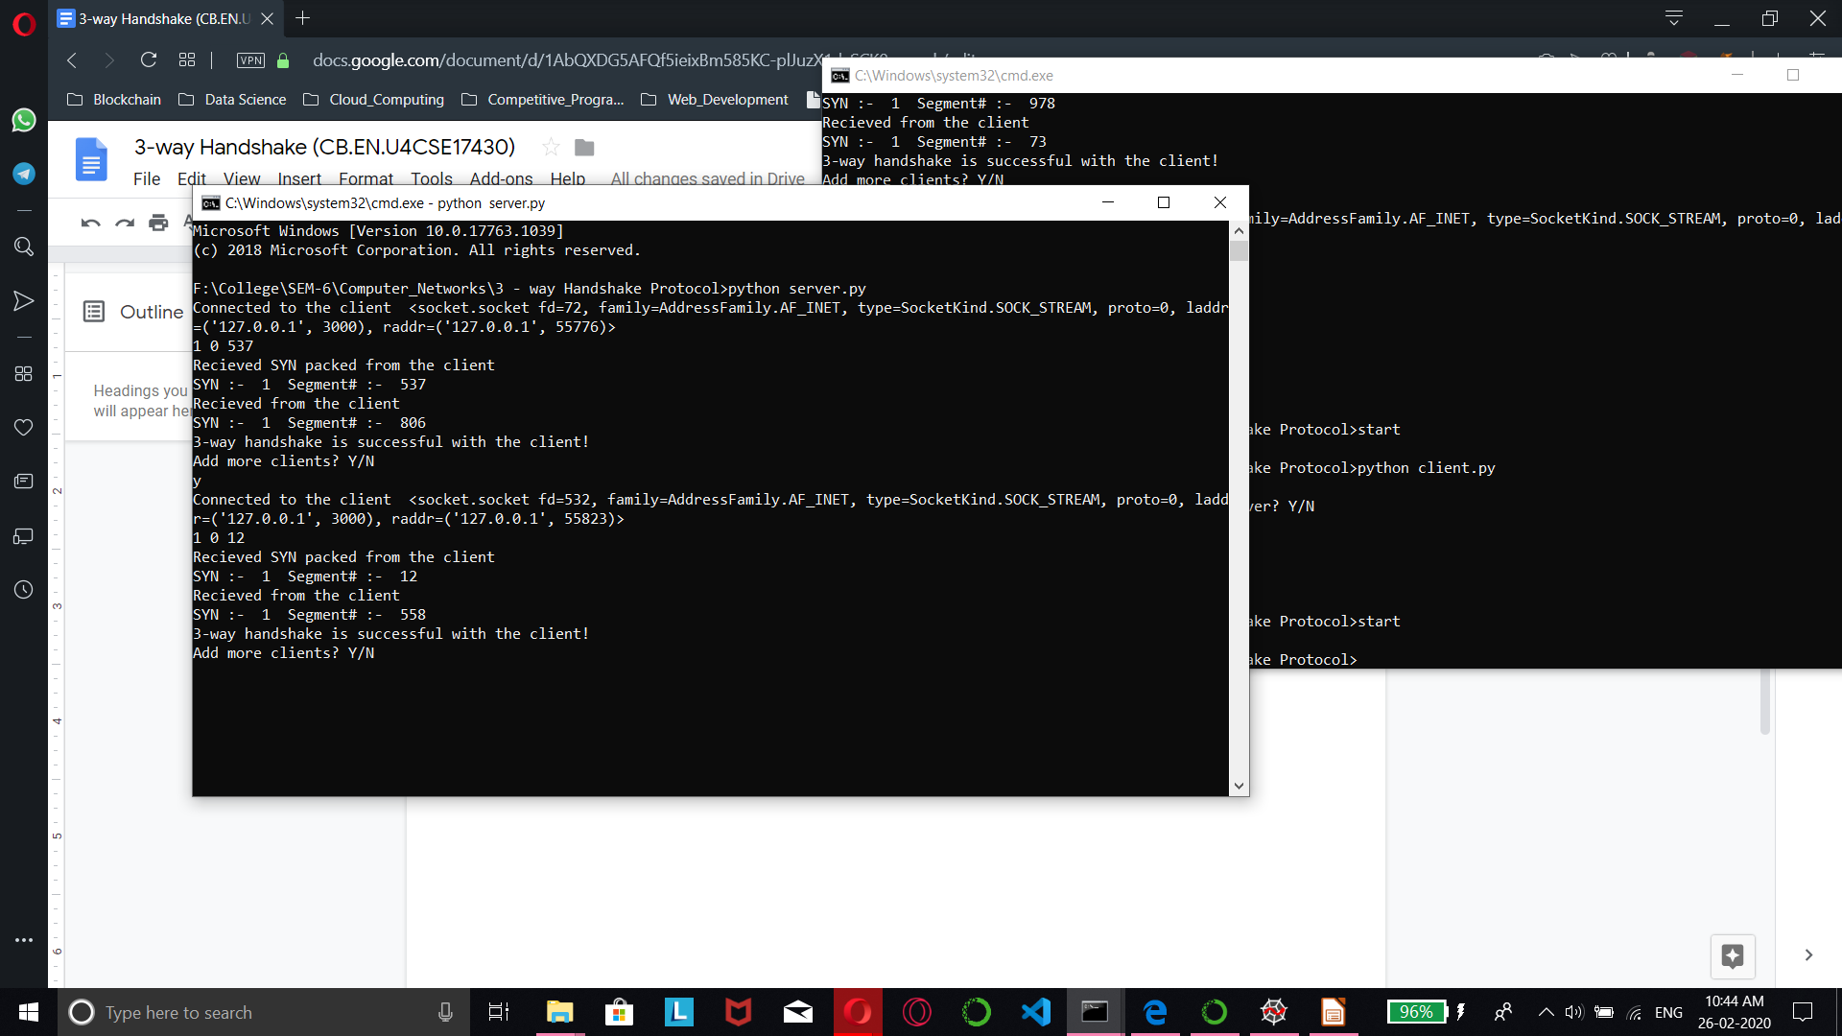

Client:

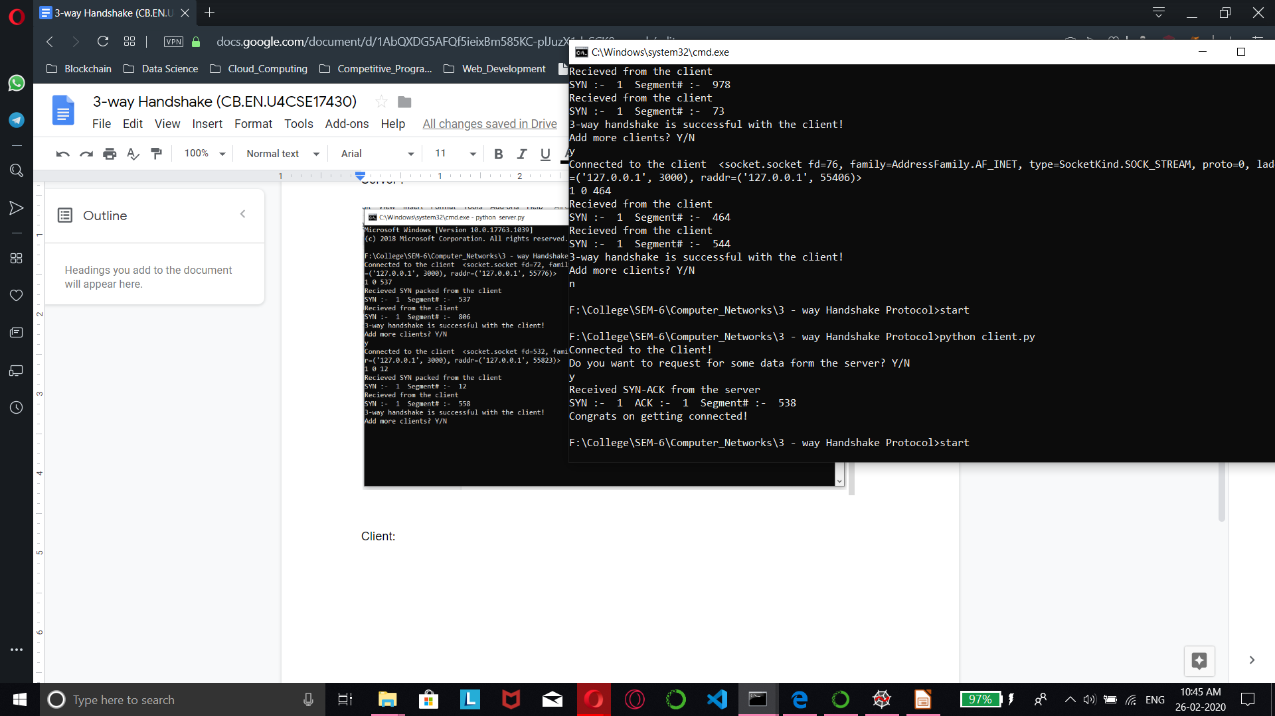

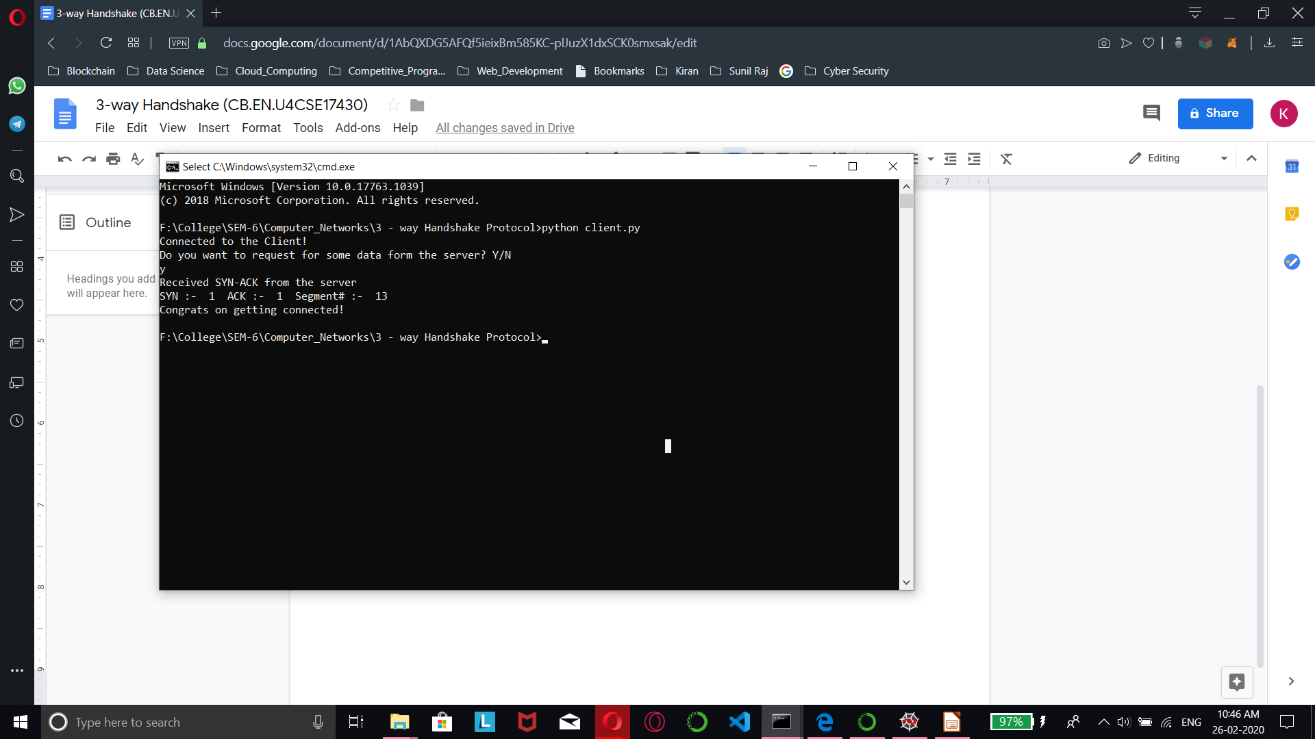

Sever_Code:

import socket

import random

s = socket.socket()

s.bind(('',3000))

s.listen(5)

forward = dict()

ind = 0

while True:

c, addr = s.accept()

if(c not in forward.values()):

forward[ind] = c

ind+=1

print("Connected to the client ",c)

c.send(bytes("200","utf-8"))

data = c.recv(1024).decode("utf-8")

print(data)

segment = data.split()

print("Recieved SYN packed from the client")

print("SYN :- ", segment[0]," Segment# :- ",segment[2])

segment[2] = int(segment[2]) + 1

segment[1] = int(segment[1]) + 1

message = ""

for i in segment:

message += str(i) + " "

c.send(bytes(str(message),"utf-8"))

data = c.recv(1024).decode("utf-8")

segment = data.split()

print("Recieved from the client")

print("SYN :- ", segment[1]," Segment# :- ",segment[2])

print("3-way handshake is successful with the client!")

print("Add more clients? Y/N")

x = input()

if(x=='y' or x=='Y'):

continue

else:

break

Client_Code:

import socket

import random

s = socket.socket()

s.connect(('127.0.0.1',3000))

while True:

conf = s.recv(1024).decode("utf-8")

if(conf == "200"):

print("Connected to the Client!")

print("Do you want to request for some data form the server? Y/N")

x = input()

if(x=='Y' or x=='y'):

r1 = random.randint(0,1000)

message = "1 0 "+str(r1)

s.send(bytes(str(message),"utf-8"))

data = s.recv(1024).decode("utf-8")

segment = data.split()

print("Received SYN-ACK from the server")

print("SYN :- ", segment[0]," ACK :- ",segment[1]," Segment# :- ",segment[2])

r1 = random.randint(0,1000)

message = "0 1 "+str(r1)

s.send(bytes(str(message),"utf-8"))

print("Congrats on getting connected!")

break